Azure Active Directory Authentication (using adal.js) and application registration

# Azure Active Directory Authentication using adal.js

## Register Application in Azure Active Directory

Any application that wants to use the capabilities of Azure AD must first be registered in an Azure AD tenant. During registration process, Azure AD needs some information about your application like your application URL, callback URL after a user is authenticated

First, access to Azure portal (<https://portal.azure.com>) and go to Azure Active Directory

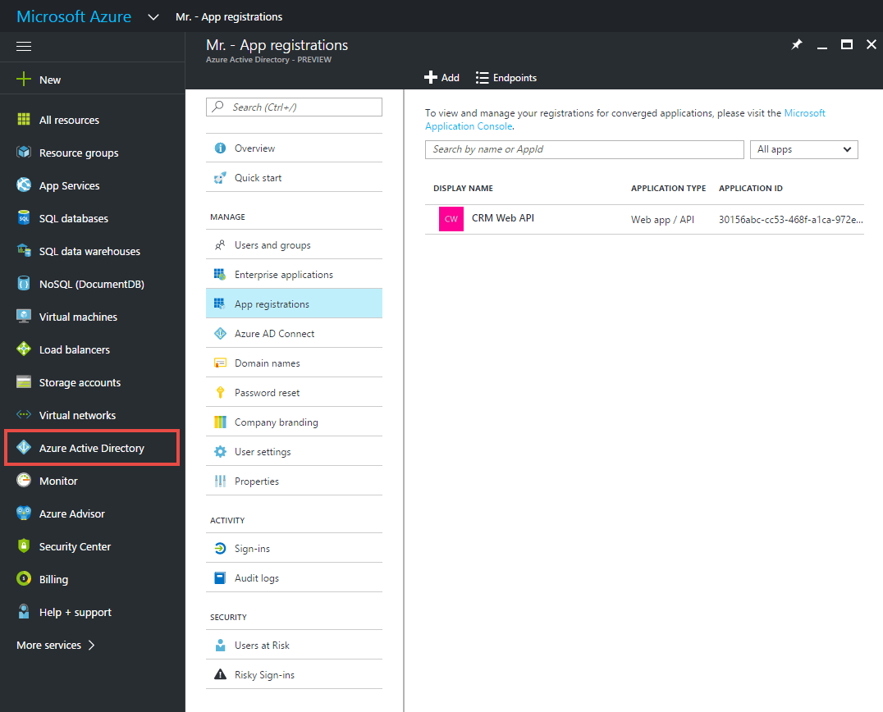

From App Registrations, Add new application

You need to specify a name for your application and select Application Type also. There are 2 applications type that you can select: Web app/API or a Native client application. In this sample we will choose Web app/API

Depend on your application is a web or native application, you will see different options on steps to add your application

In this sample, we will put Sign-on URL as our home page (e.g <http://localhost:61950/Portal/Sample.html>)

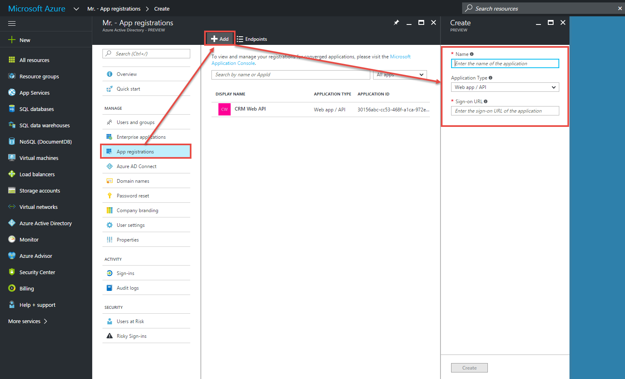

## Enabling OAuth 2.0 implicit grant for Single Page Applications

### What is OAuth2 implicit grant ?

The OAuth2 implicit grant is a variant of other authorization grants. It allows a client to obtain an access token directly from the authorization endpoint, without contacting the token endpoint nor authenticating the client. It’s designed for JavaScript based applications, especially for Single Page Applications (SPAs). By that way, our application can invoke APIs (like Microsoft Graph API, Office API, Azure API) outside the domain where the application is hosted

### How to enable OAuth 2.0 implicit grant

Once our application is registered, select on that app, select Manifest file and download this file

Open Manifest file and update **“oauth2AllowImplicitFlow”** value to **true**

Upload Manifest file to your application

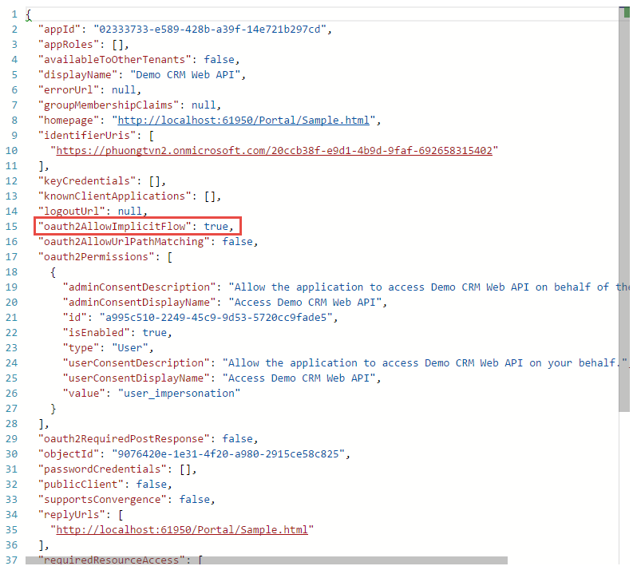

### Add permission for your application

From application, add permission for user to access your Dynamics CRM App

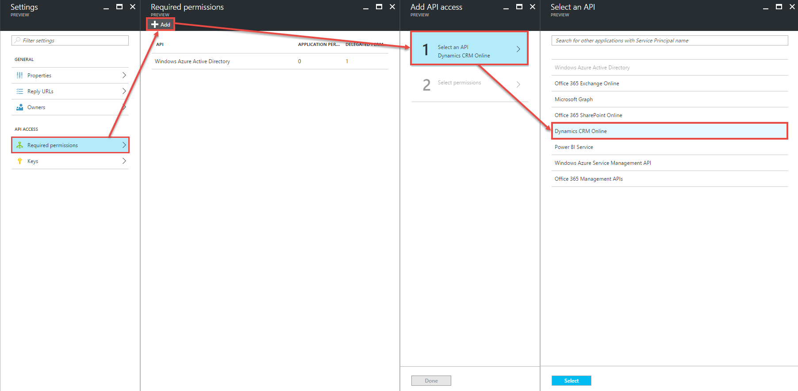

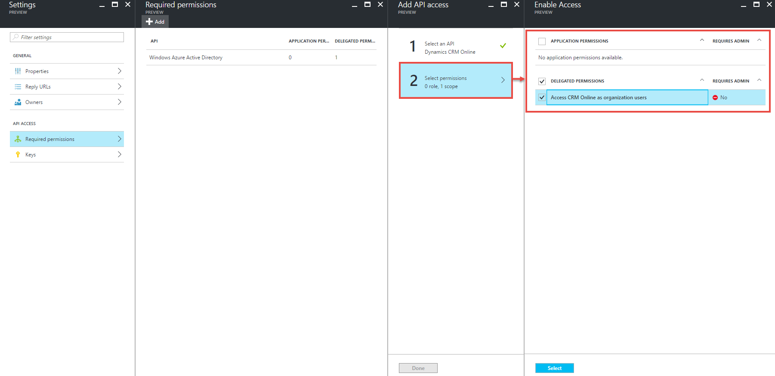

## Authentication for web application using adal.js

Base on library from <https://github.com/Scaleable-solutions/WebAPIAuthFromJavaScript>, I fixed some issued that happened when losing cookie or token expired and updated into **util.js**

We need to update configuration for our application before using Dynamics CRM 365 Web API

var organizationURI = "https://<ORG_NAME>.api.crm5.dynamics.com"; // TODO: Add your organizationURI

...

var tenant = "b5101e80-6255-4e07-afed-380b2d3bdd51"; // TODO: add your tenant

var clientId = "30156abc-cc53-468f-a1ca-972e1c3b02d6"; // TODO: Add your Client Id

var pageUrl = "http://localhost:61950/Portal/Sample.html";// TODO: Add your Reply URL

**ClientId**: Your Application ID when you register your app into Azure AD

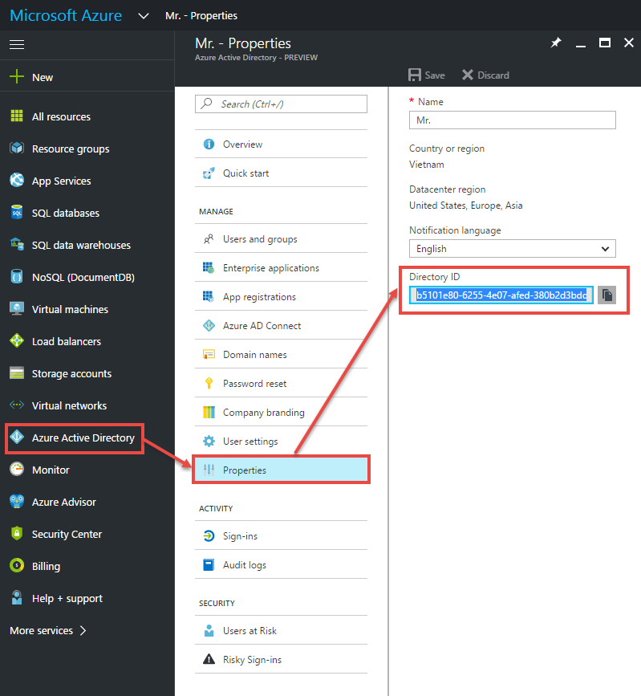**TenanID**: Your Directory ID (in Azure Active Directory) – see image below

Once web page is loaded, we will run **authenticate()** function for checking whether token is available or not

function authenticate() {

var isCallback = authContext.isCallback(window.location.hash);

if (isCallback) {

authContext.handleWindowCallback();

}

var loginError = authContext.getLoginError();

if (isCallback && !loginError) {

window.location = authContext._getItem(authContext.CONSTANTS.STORAGE.LOGIN_REQUEST);

}

else {

//errorMessage.textContent = loginError;

//alert(loginError);

}

if (authContext._loginInProgress == true) {

return;

}

user = authContext.getCachedUser();

var hasToken = true;

if (authContext._getItem(authContext.CONSTANTS.STORAGE.EXPIRATION_KEY + organizationURI) == 0 ||

authContext._getItem(authContext.CONSTANTS.STORAGE.RENEW_STATUS + window.config.clientId) == authContext.CONSTANTS.TOKEN_RENEW_STATUS_COMPLETED) {

authContext.acquireToken(organizationURI,

function (error, token) {

if (!token) {

console.warn("Cannot find token");

hasToken = false;

return false;

}

if (isCallback) {

authContext.handleWindowCallback();

}

});

}

if (hasToken == false)

return;

var token = authContext.getCachedToken(organizationURI);

if (user && token != null) {

displayLogin();

}

}

For login button, we will add login function from authentication context (adaj.js) to redirect user to Azure AD authorization endpoint

document.getElementById('login').addEventListener('click', function () {

login();

})

function login() {

authContext.login();

}